## Getting Up and Running with the Power BI Service

**Setup Time**: 60 minutes

**Lab Folder**: C:\Student\Modules\01_IntroToPowerBI\Lab

**Overview**: This lab covers how to get up and running with Power BI by creating a new Office 365 tenant with trial subscriptions to Office 365 and Power BI Pro. The act of creating and configuring this new Office 365 tenant will yield an isolated testing and development environment for working on projects with the Power BI service and using Microsoft’s latest self-service BI tools such as Power BI Desktop and Microsoft Excel 2016. One valuable aspect of creating a new and isolated Office 365 tenant is that you will have tenant-level administrative permissions allowing you to configure the tenant with multiple user accounts for testing your Power BI projects in isolation from any existing Office 365 tenancy.

### Exercise 1: Create a new Office 365 Trial Tenant

In this exercise, you will create a new Office 365 tenant which allows you to create up to 25 user accounts with Enterprise E5 trial licenses. Note that the Enterprise E5 trial license provides the benefits of the Power BI Pro license. Being able to create multiple Office 365 user accounts in your Power BI testing environment will be important so that you can test the effects of sharing Power BI dashboards between users.

1. Navigate to the following URL:

<https://go.microsoft.com/fwlink/p/?LinkID=698279&culture=en-US&country=US>

1. Fill out the form with your personal information and click **Next**.

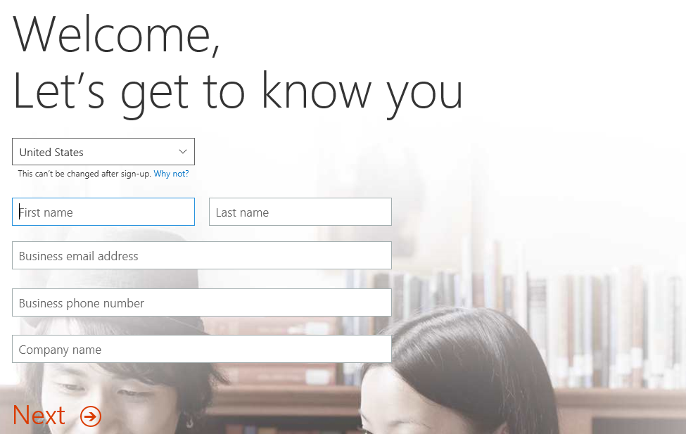

The information you provide here will be used throughout your tenant so if you do not wish to use your actual company name then provide humorous and fictitious company name. The name you use for company name will turn out to be the name of the trial Office 365 tenant that you are creating.

1. On the next page, you are prompted to provide a user ID, company name and password.

Note that the company name you enter on this page will be used to create the domain name for your new Office 365 trial tenant. For example, if you were to enter a company name of **CptPowerBiTenant**, it would result in the creation of a new Office 365 tenant within a domain of **CptPowerBiTenant.onMicrosoft.com**. The user name you enter will be used to create the first user account which will be given administrative rights within the trial tenant. If you enter a user name of **Student**, then the email address as well as user principal name for this account will be **Student@CptPowerBiTenant.onMicrosoft.com**.

1. Enter a user name and a company name for your new Office 365 trial tenant. For the company name, you may wish to simply use your first and/or last name with a number which you can increment each time you have to create a new trial account (e.g. EricClapton1.onmicrosoft.com).

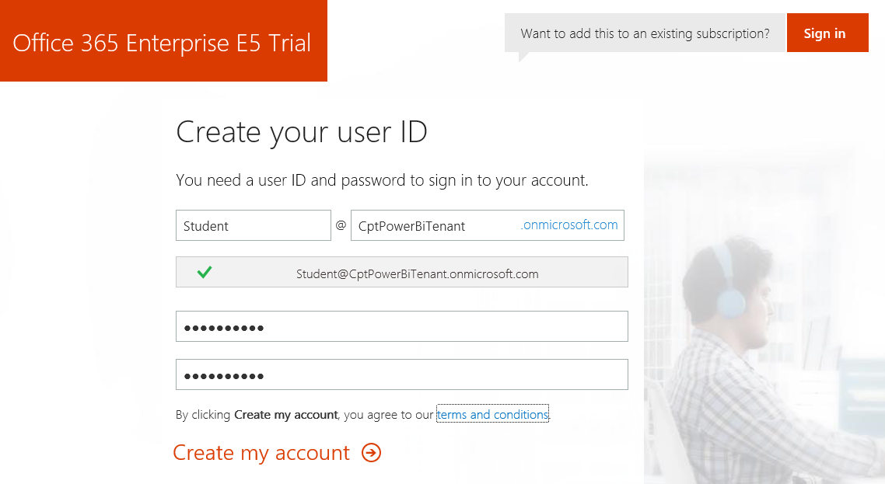

Don’t use your actual company name as that may cause some conflict when your company decides to create their own official tenant. Throughout the remainder of this guide you will see a company domain name of **CptPowerBiTenant** which you should replace with the value specified for your company name.

1. Click **Next** to continue to step 3.
2. Complete the validation form in step 3 by proving you are not a robot.
   1. Select the **Text me** option and provide the number of your mobile phone.
   2. When you go through this process, a Microsoft service will send you a text message that contains an access code.
   3. You retrieve the access code form your mobile device and use it to complete the validation process.



1. Once you have completed the validation process, click the **You’re ready to go…** link to navigate to the portal welcome page for your new Office 365 trial tenant. Note that you should already be logged on using the user account that was created during the sign up process.

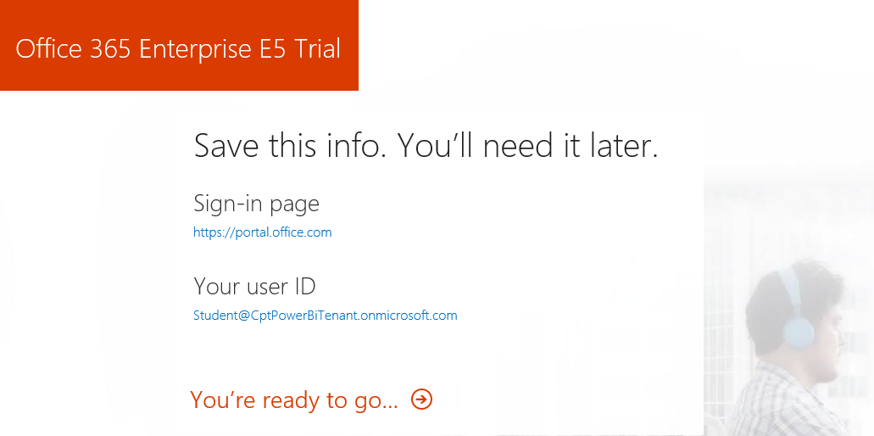

At this point, you have already created your new Office 365 tenant which can support creating up to 25 user accounts with Office 365 Enterprise E5 trial licenses. Note that some Office 365 services within your new Office 365 tenant such as the Office 365 admin center can be accessed immediately. Other services within your Office 365 tenant such as SharePoint Online are not ready immediately and will take some time to provision.

1. At this point, you should be located on the portal welcome page of Office 365. You will notice that this page shows the progress of the Office 365 environment in setting up each of the individual services that make up your new Office 365 tenant. Click the **Admin** tile to proceed to the Office **365 admin center**.

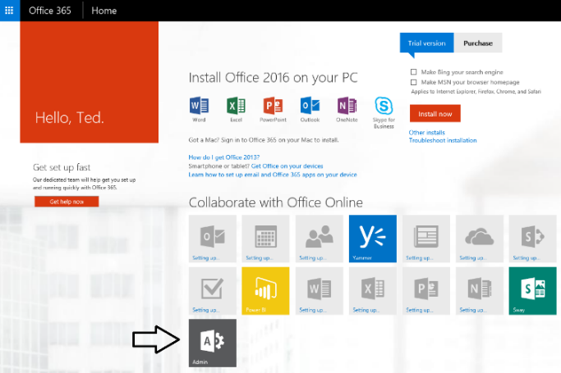

In of April 2016, Office 365 introduced a new user interface experience of the Office 365 admin center which is currently in preview. While it will be possible for you to fall back on the older UI experience for the Office 365 Admin center, we assume you will use the new preview edition so that is what we will show in the screenshots for this lab.

1. If you are presented with the Office 365 admin center welcome dialog, close it by clicking the **X** menu in the upper right corner.

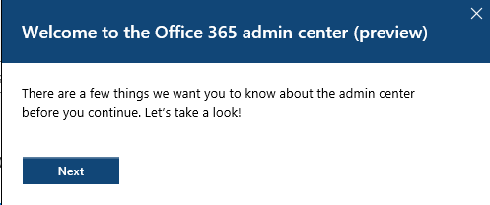

1. Verify that you are able to access the home page of the **Office 365 admin** **center**.
   1. The following screenshot shows the Office 365 Admin with the introduction of the new user interface experience that was introduced in April of 2016.

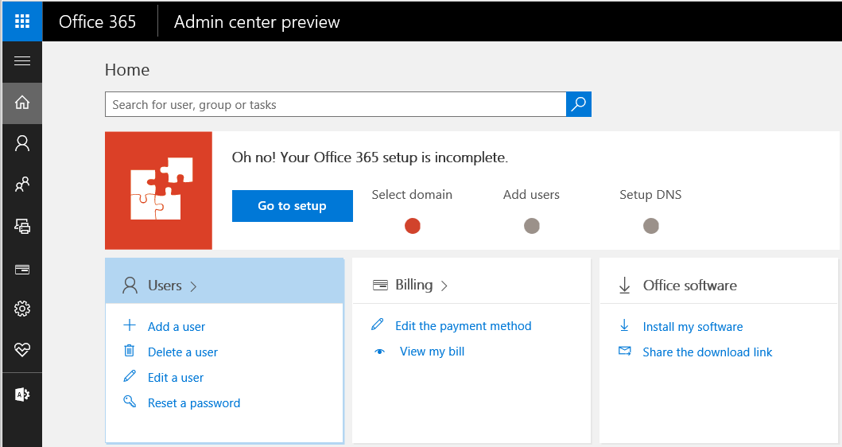

* 1. Locate the top **Menu** button for the left navigation menu. It’s the second button from the top which sites just beneath the Office 365 App Launcher menu button.

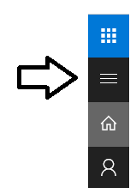

* 1. Click the top **Menu** button several times and see how it toggles the left navigation between a collapsed and expanded mode.

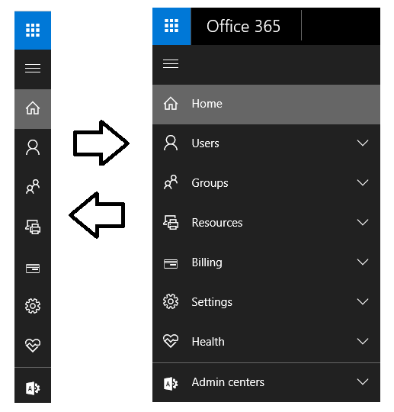

If you are interested in getting more familiar with the **Office 365 admin center**, take a minute to explore the administrative pages behind the left navigation menu in the Office 365 admin center.

1. Make sure you can access mail and your Office 365 inbox.
   1. Click on the Office 365 App Launcher menu button in the top-left corner of the page.



* 1. Click the **Mail** tile button in the App Launcher menu to navigate to the Exchange Online inbox for the current user.

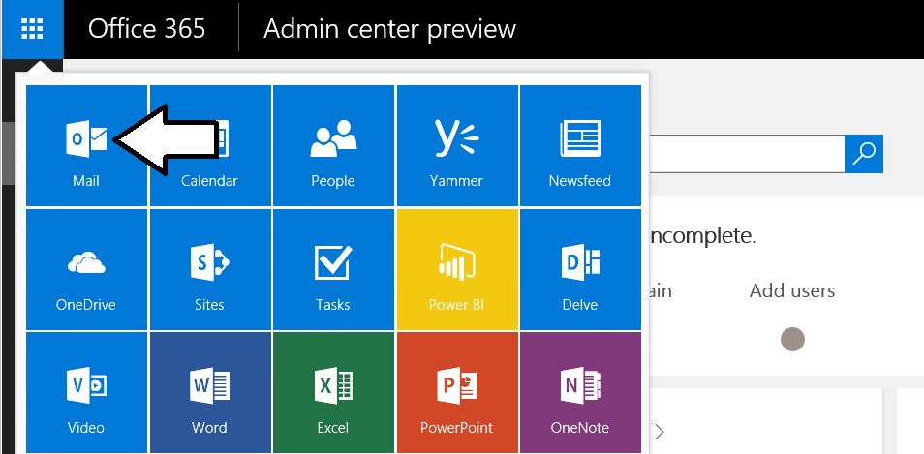

* 1. If prompted, specify your language and time zone for Outlook.



* 1. You should now see a web page with the Office 365 Outlook web access client and a view of the Exchange inbox that is associated with the primary user account that was created when you created the Office 365 tenancy.

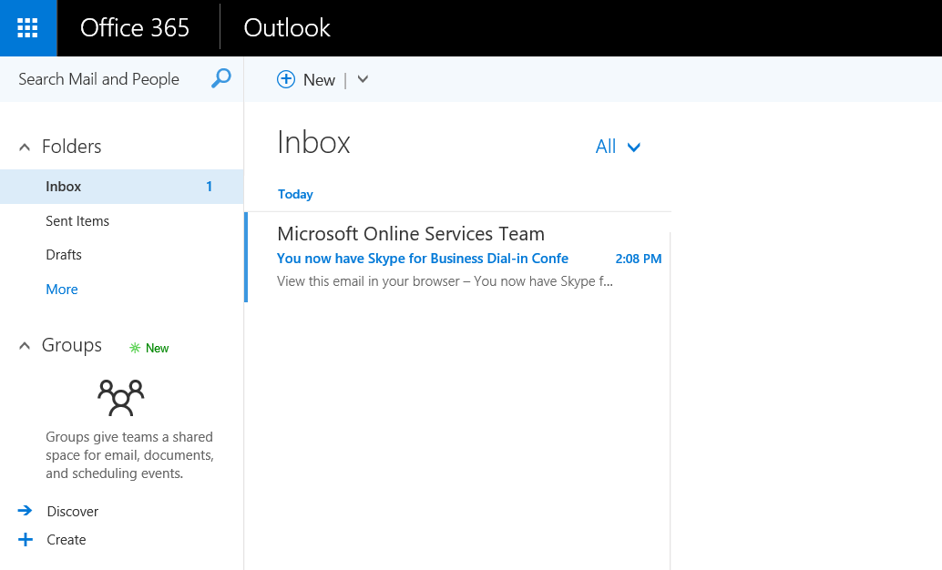

* 1. Test email by sending a message to one of your other email addresses, Display the form to create a new email clicking the **New** button. If the **New** button is not showing, it’s probably because the form to create a new email is already showing.

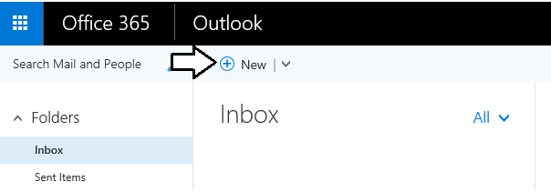

* 1. At this point, you should see the Outlook form to create new email on the right side of the page.

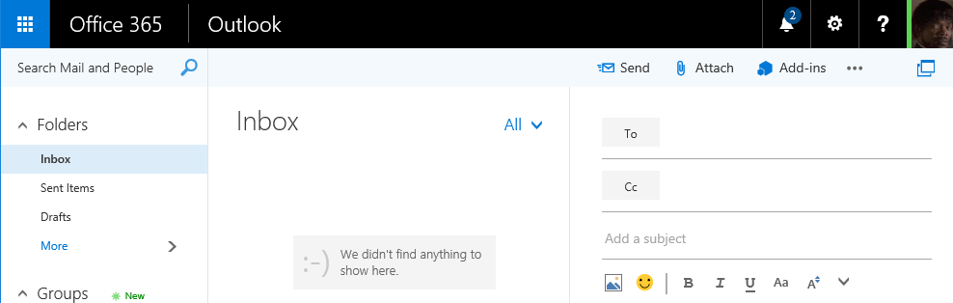

* 1. Fill out the new email form using sample data (see example below) to send a test message. Be sure to send the test message to an email address that is yours. Click **Send** when it’s ready to go.

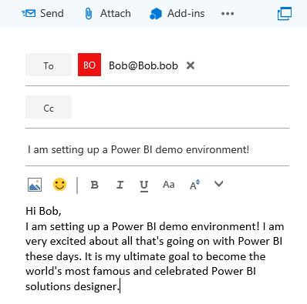

* 1. Click **Send** to send the email.
  2. Check the email account you sent the email to and verify that you received the email.
  3. Reply to the email to verify that you can send an email to your new account.
  4. Return to the Outlook Web Client and verify receipt of your reply.

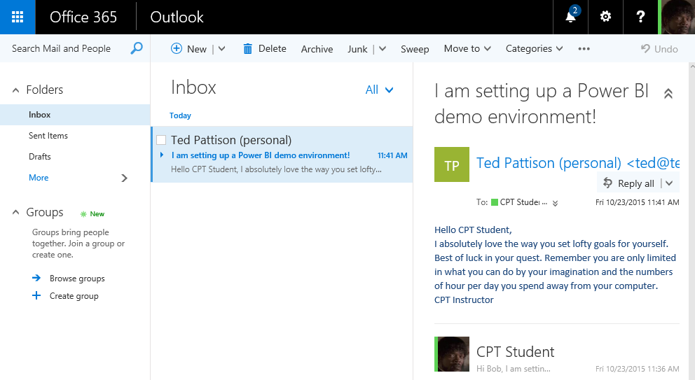

Having access to mail is valuable when you are working with Power BI. That's because the Office 365 and the Power BI service use email messages to send invitations and notification to users is response to user actions such as creating a new group workspace or sharing a dashboard.

### Exercise 2: Install the Desktop Version of Microsoft Office 2016 Pro

In this exercise you will install Office 2016 Pro using software downloaded directly from the Office 365 portal. The main reason you need to install Office 2016 Pro is that you will be using Microsoft Excel 2016 in later lab exercises.

1. Install the Office 2016 client applications.
   1. In the browser, navigate to <https://portal.office.com>.
   2. Locate and click on the **Other Installs** link on the page.

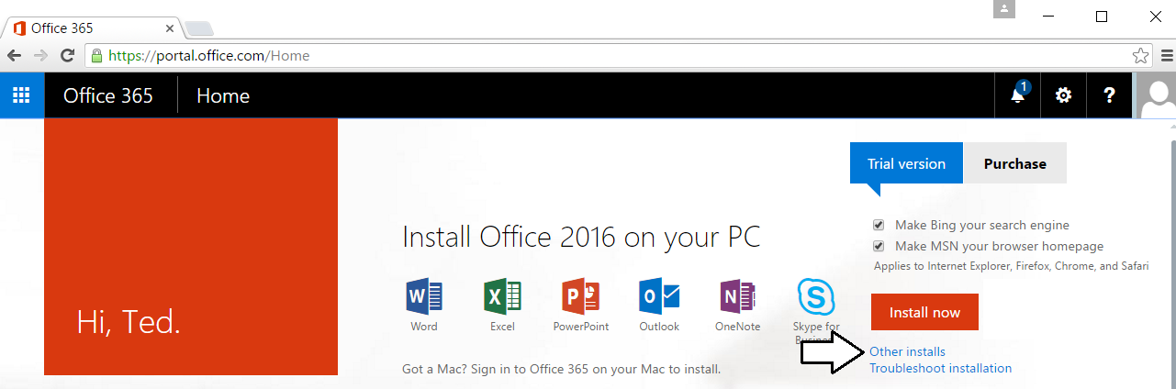

Don't click the **Install Now** button. That will install the 32-bit version of Office 2016 when instead you want to install the 64-bit version.

* 1. You should now be at the **Office** tab of the **Software** page. Locate and click the **Advanced** link to set the installation option to install the 64-bit version of Office 2016 instead of the 32-bit version.

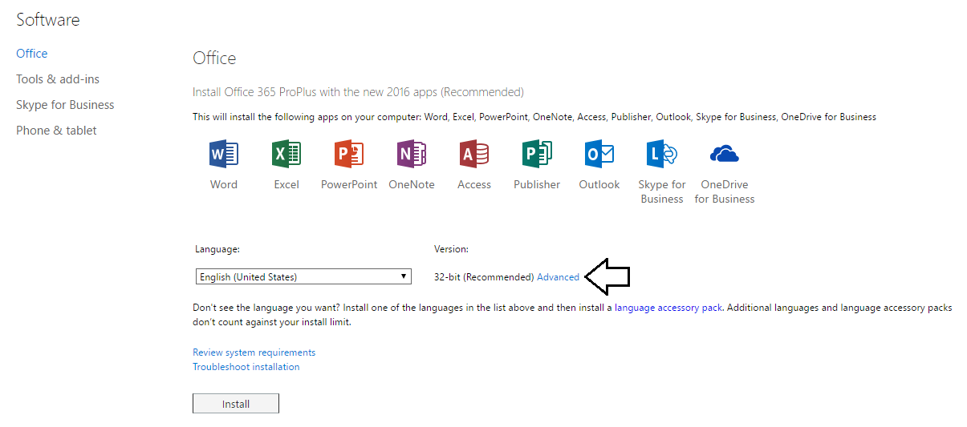

* 1. Use the dropdown menu to change the Version setting to **64 bit**. And then click the **Install** button to begin the installation.

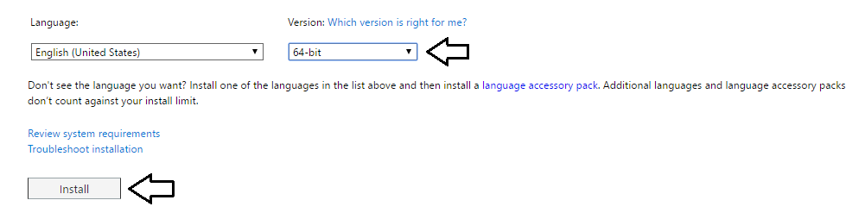

* 1. Follow the instructions to install Office 2016.

Note that you can move on to the next exercise and continue working while you're waiting for the Office 2016 installation to complete.

1. When you see the Success dialog indicating the installation of Office 2016 Pro is completed, complete the following steps.
   1. Launch Microsoft Excel to verify the installation of Office 2016 Pro.
   2. When prompted to activate Office 2016 Pro, use the email of your new Office 365 account to complete the activation process.

### Exercise 3: Upload a Workbook with Sample Data to OneDrive for Business

In this exercise, you will upload an Excel workbook file containing sample data to OneDrive for Business. However, the first step will to download a copy of the sample Excel workbook to your local hard drive.

1. Ensure you have downloaded the **Student.zip** file associated with this training course and extracted the contents of this zip archive into a local direct at **C:\Student**.
2. Locate the sample Excel workbook file at the following path.

C:\Student\Data\WingtipSalesData.xlsx

You can also download this file from <https://github.com/CriticalPathTraining/PBI365/raw/master/Student/Data/WingtipSalesData.xlsx>

1. Open OneDrive for Business by clicking the **OneDrive** icon in the Office 365 App Launcher.

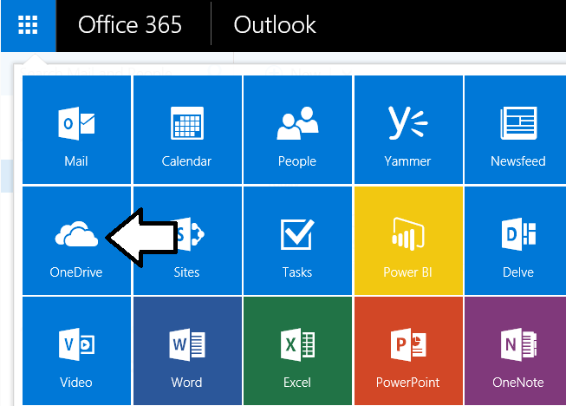

1. If you are prompted by the **Get the most out of SharePoint** dialog, click **No Thanks** button to dismiss this dialog.
2. When you first navigate to your OneDrive for Business site, you will be prompted with the following page. Click **Next**.



1. You should now be at the main landing page for **OneDrive for Business** which displays the **Documents** library.



1. Click the **Upload** button and go through the steps to upload the local copy of **WingtipSalesData.xlsx** to the **Documents** library. Once you have completed this step, you should be able to verify that the **Documents** library contains **WingtipSalesData.xlsx**.



1. Inside the **Documents** library, locate and click on the **WingtipSalesData** link to open the workbook in Excel Online. As you can see, the workbook contains a sample set of tabular data that will be used in a later exercise.

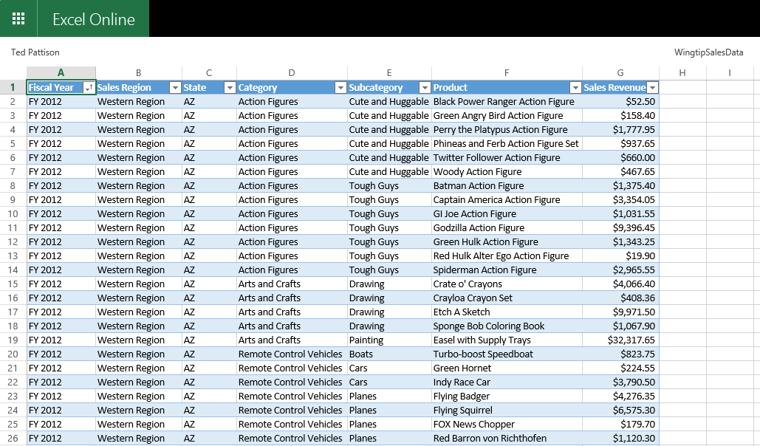

Now you have uploaded an Excel workbook with sample data to a OneDrive for Business site. In an upcoming exercise, you will use the data inside this Excel workbook to create a dataset, a report and a dashboard in the Power BI service.

### Exercise 4: Add a Secondary User Account for Testing Purposes

In this exercise, you will configure your new Office 365 tenant by creating a secondary user account that you will need later when you begin experimenting with the Power BI dashboard sharing process.

1. Return to Office 365 admin center by clicking the **Admin** icon in the Office 365 App Launcher.
2. Inspect the set of Active Users in the current tenancy.
   1. In the left navigation menu, expand the **Users** node and click **Active Users** to navigate to the **Active Users** page.

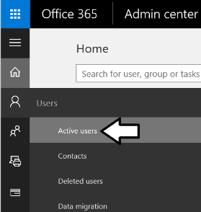

* 1. Once the **Active Users** page is displayed, you should be able to verify that the user account you are currently logged on as is the only user account that exists in the current tenancy. Remember that this account has been set up as a Global Administrator to the tenant because it is the account that was used when creating the tenant.

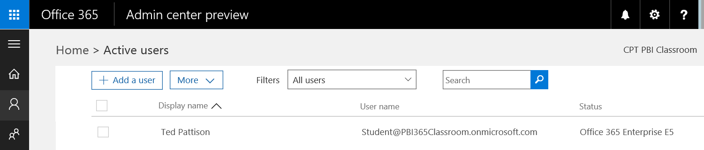

1. Create a new user account.
   1. On the **Active Users** page, click the button **Add a user** button to create a new user account

. 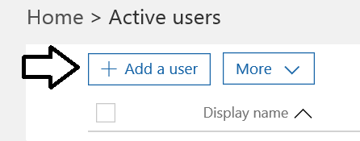

* 1. Fill in the **Create new user account** form with information for a new user account. When creating this account, you can use any name you would like. These lab instructions will demonstrate this by creating a user account for a person named **James Bond** with a user name and email of **JamesB@CptPowerBiTenant.onmicrosoft.com**.

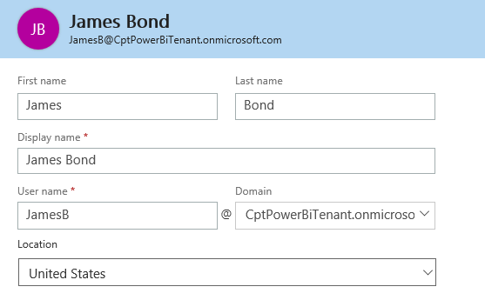

* 1. Expand **Password** section under **Contact Information** section.
     1. Select the option for **Let me create the password**.
     2. Enter a password of **pass@word1** into the textboxes labeled **Password** and **Retype** **Password**.
     3. Uncheck the checkbox for the option labeled **Make this user change their password when they first sign in**.

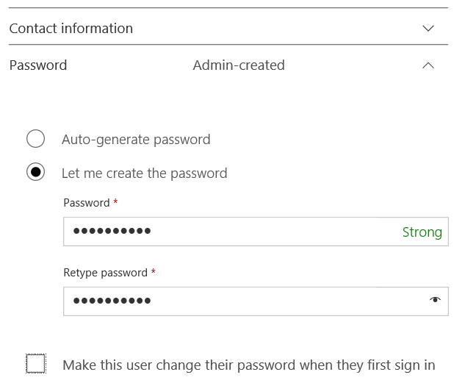

* 1. Expand the roles section. You do not need to change anything in this section, although you should note that this new user account will be created as a standard user account without any administrator access or privileges.

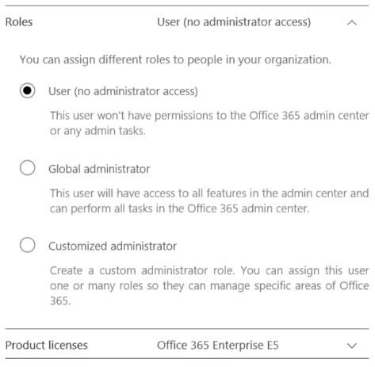

Note that the new account has been automatically assigned trial license for **Office 365 Enterprise E5** plan. That means you do not need to do anything further to enabled support for Power BI. Having the for **Office 365 Enterprise E5** license provides the same level access as a **Power BI Pro** license.

* 1. Click the Save button at the bottom of the new user form to create the new user account.

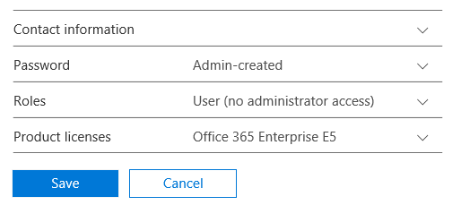

* 1. When you see the **User was added** message, click **Send email and close** to dismiss the **Add new user** task pane.
  2. Verify that the new user account has been created and is displayed along with your primary user account.

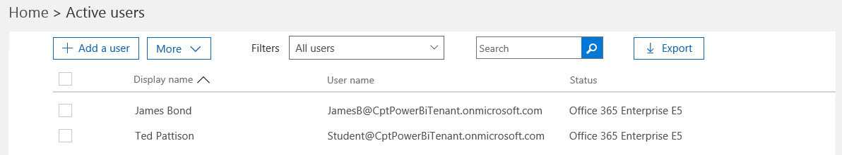

### Exercise 5: Use the Power BI Service to Import a New Dataset

Now, after all that busy work, you are finally ready to begin working with Power BI. In this exercise you will begin by importing data from an Excel workbook to create a new Power BI dataset. In the exercise steps that follow, you will create a report and a dashboard.

1. In the browser, navigate to the Power BI service by clicking the **Power BI** icon in the Office 365 App Launcher. If you are prompted to log on, make sure you log on using the same primary Office 365 user account that you created earlier when you created the Office 365 trial account. In other words, sign on with the administrator account and not with the secondary user account you created in the previous exercise.

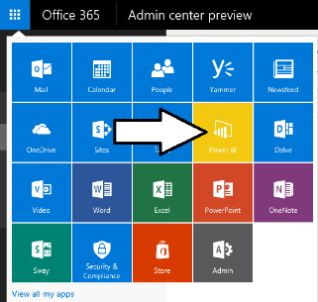

What usually happens when you click the **Power BI** tile in the Office 365 Application Launcher is that you will navigate to the page that shows the dashboards, reports and datasets in your personal workspace. However, your personal workspace is initially empty so it doesn’t contain any dashboards, reports or datasets yet. Therefore, the Power BI service display a special welcome page that allows you to get started by linking to or importing data.

1. At this point, you should be at the Welcome to Power BI page as seen in the following screenshot.

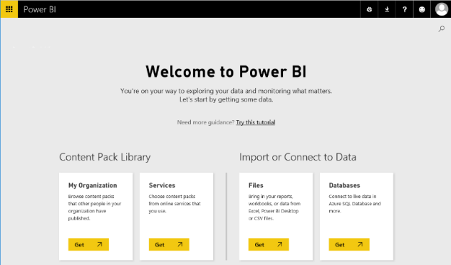

1. Import data from an Excel workbook file.
   1. Click in the **Get** button in the **Files** tile under the **Import or Connect to Data** section header.

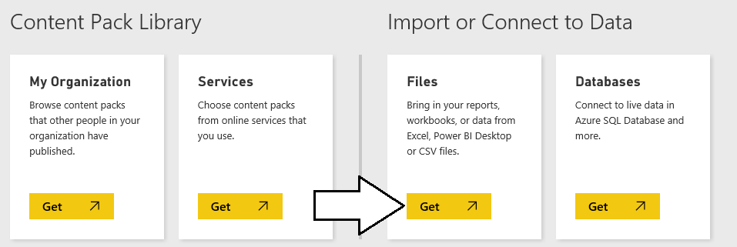

* 1. On the next page you should see several tiles which indicate your choices for the location of the file you would like to connect to or import. Click on the tile with the caption **OneDrive – Business** so you can import data from the Excel workbook you uploaded to your OneDrive site in a previous exercise.

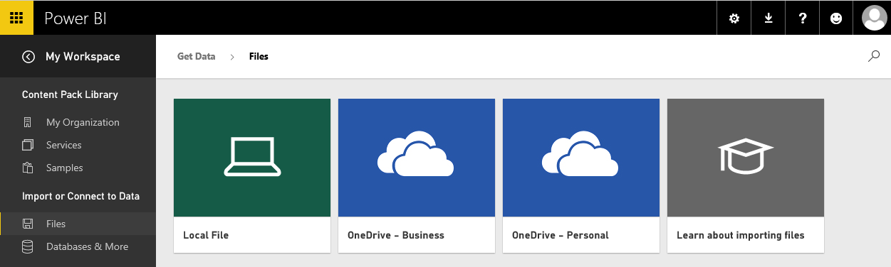

* 1. One the **OneDrive for Business** page, select the workbook named **WingtipSalesData.xslx** and then click the **Connect** button on the top right-hand side of the page.

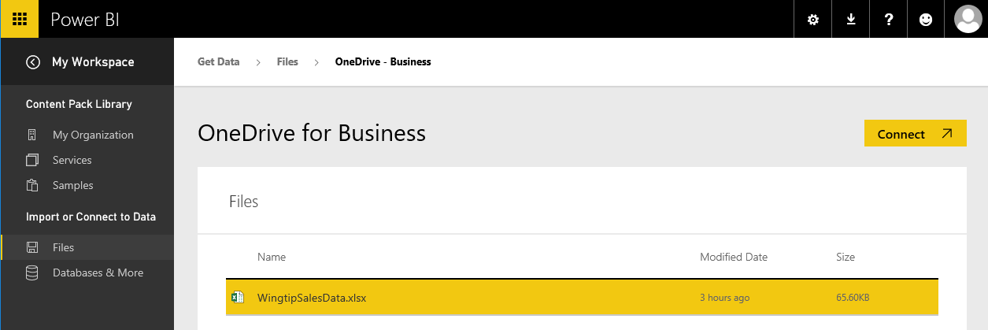

* 1. After clicking the **Connect** button in the previous step, you are taken to a page which prompts you to **Choose how to connect to your Excel workbook**. Click the **Import** button on the bottom left-hand side of the page to import data from the Excel workbook into the Power BI service to create a new dataset.

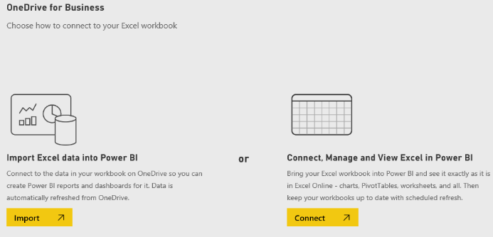

At this point you might make the observation that Microsoft has worked to streamline the user experience in Power BI when working with data files that have been uploaded to OneDrive sites. Once you upload your data files to a OneDrive site, they are very easy to access and integrate into your Power BI workspaces.

* 1. After the import process has completed, the Power BI service will display a dashboard that was created during the import of the file **WingtipSalesData.xlsx**.

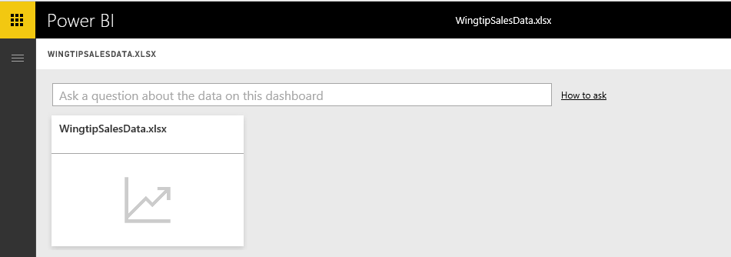

1. Expand the left navigation menu.
   1. Click the top menu button for Power BI directly below the Office 365 App launcher to expand the left navigation menu.

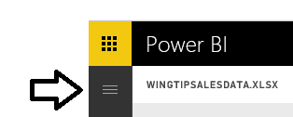

* 1. Once you have expanded the left navigation menu, you should be able to see that the import process has created a dashboard named **WingtipSalesData.xlsx** and a dataset named **WingtipSalesData**.

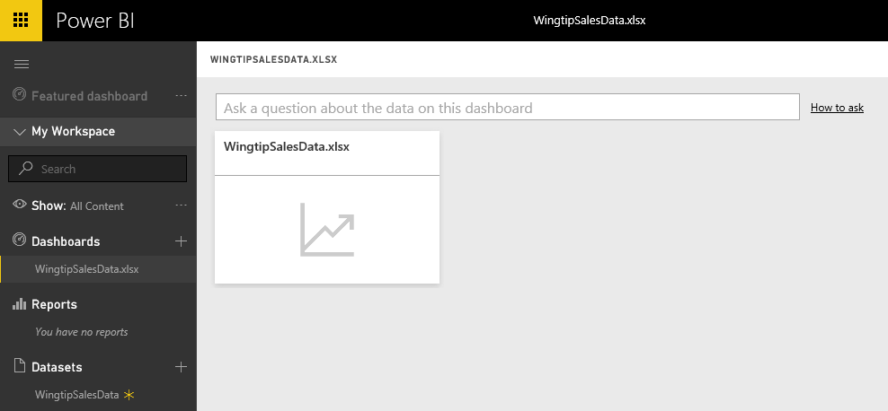

Note that when importing data from an Excel workbook that the Power BI service creates both a new dataset and a new dashboard. However, you might want just the dataset but not the dashboard. Feel free to delete the dashboard if you do not need it.

1. Delete the dashboard named **WingtipSalesData.xslx**.
   1. Expand the ellipse menu to the right of the **WingtipSalesData.xlsx** dashboard and selecting the **REMOVE** command.

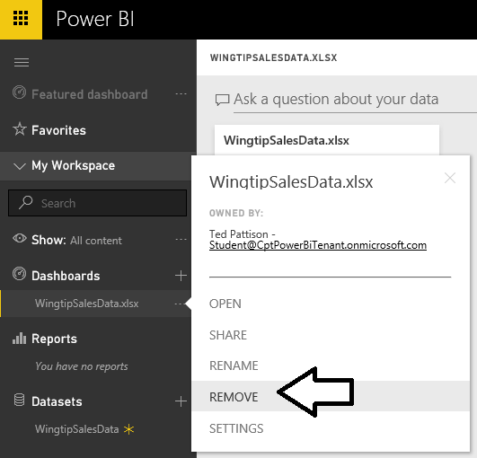

* 1. When prompted, confirm you want to delete this dashboard.

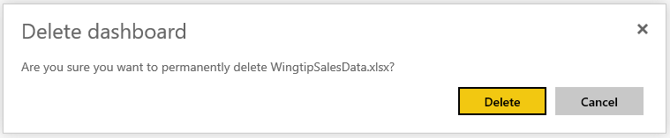

* 1. Your personal workspace now contains the **WingtipSalesData** dataset but there should not be any dashboards or reports.

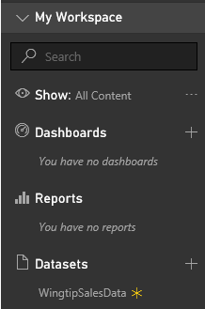

1. Expand the ellipse flyout menu (**…**) to the right of the **WingtipSalesData** dataset link just to see what menu commands are available from you to run on the new dataset you have just created.

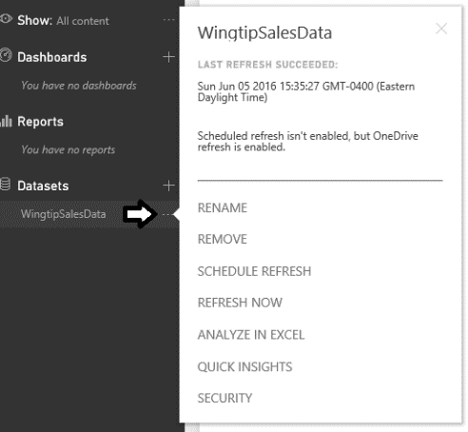

There is no need at this time to execute any of the commands in the dataset flyout menu. You should just observe the commands that you can execute on a dataset that’s been created by importing data from an excel workbook. You can see the menu commands include **RENAME**, **REMOVE**, **SCHEDULE REFRESH**, **REFRESH NOW**, **ANALYZE IN EXCEL**, **QUICK INSIGHTS** and **SECURITY**

### Exercise 6: Create a New Power BI Report with Multiple Pages

Now that you have created a dataset, the next setup step involves creating a new report with two pages of visualizations.

1. Click the **WingtipSalesData** link in the **Datasets** section of the navigation menu.

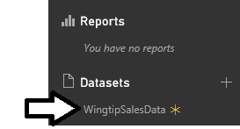

1. When you navigate to a dataset such as **WingtipSalesData**, the Power BI service displays a page in report design mode as shown in the following screenshot. Locate the **Fields** list for the dataset on the right-hand side of the page.

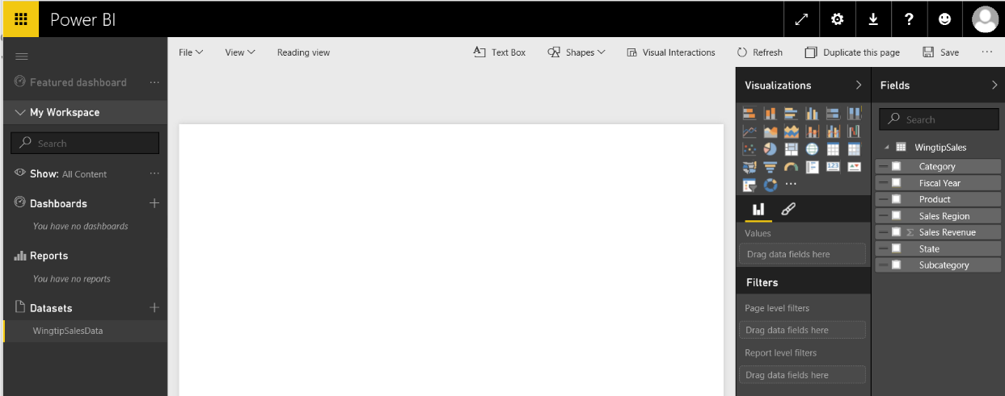

1. In the **Fields** list on the right-hand side of the page, click the checkbox beside **Fiscal Year** and then select the checkbox beside ﻿**Sales Revenue**.

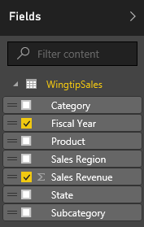

1. This should create a table visual in the new report as shown in the following screenshot.

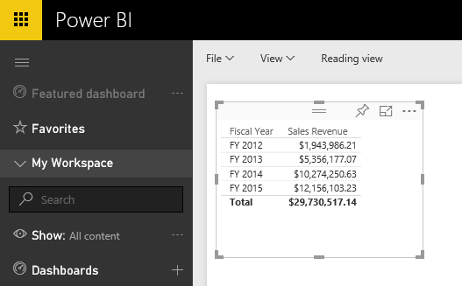

1. ﻿Change the visual type from a table to a line chart by clicking the **Line chart** button in the **Visualizations** list.

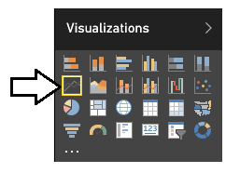

1. At this point, you should see that the visual on the report now displays a line chart.

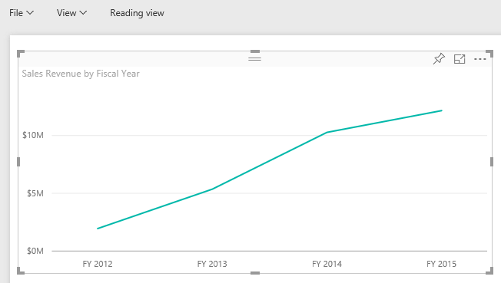

1. Next, you will add a new dimension to your visual to show how sales revenue is distributed across product categories. First, make sure the visual with the line chart is selected and then drag-and-drop the **Category** field from the **Fields** list into the **Legend** well in the **Visualizations** pane as shown in the following screenshot.

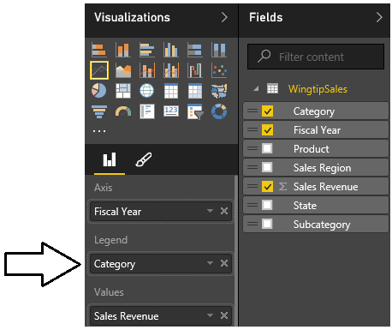

1. At this point, your visual should match the line chart shown in the following screenshot.

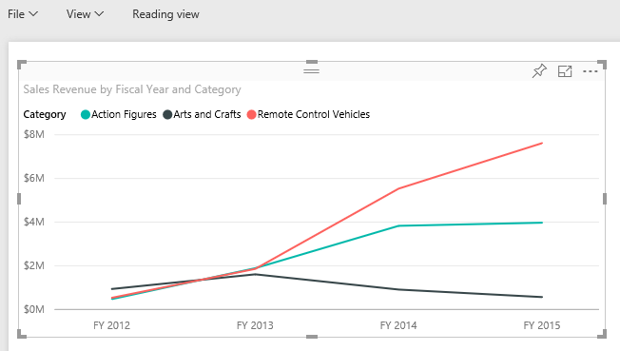

1. Select the handle at the bottom-right corner of the visualization and resize it so it takes up the width of the current report page.

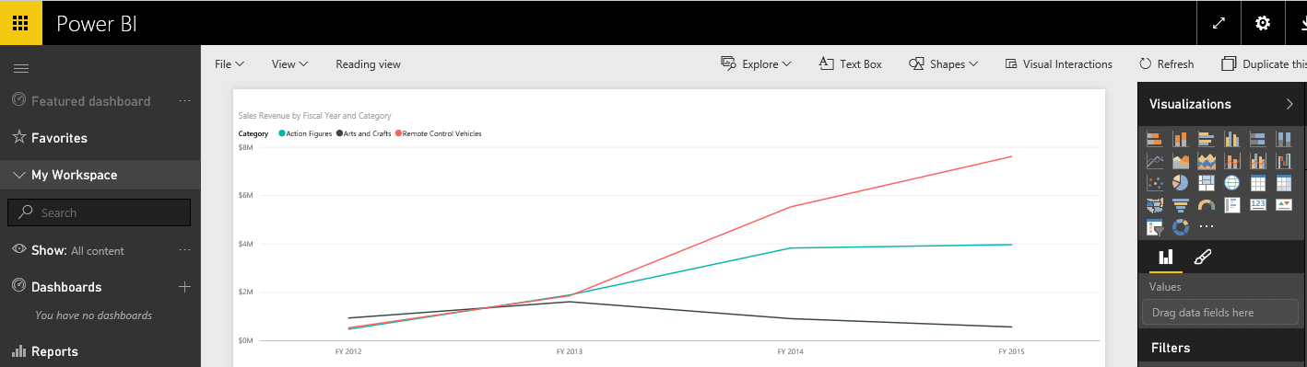

1. Reposition the Line chart’s legend.
   1. Make sure the visual with the Line chart is selected.
   2. In the **Visualizations** pane, click the pen icon to activate the **Format** properties pane.
   3. In the **Legend** section, locate the **Position** property and update it to **Right**.
   4. The legend should now be displayed in the upper right corner of the line chart visual.

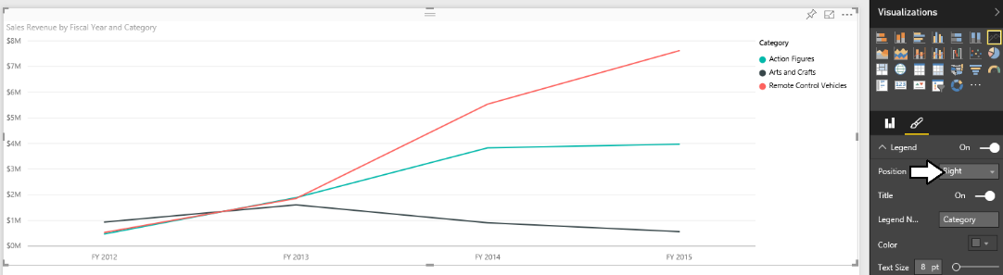

1. Now you will add a second visualization to the current report page. Begin by clicking the white space under the visualization so that the visualization is no longer selected. Next, return to the **Fields** list and select the checkbox beside the **Category** field. Next, select the checkbox beside the **Subcategory** field and then select the checkbox beside the **Sales Revenue** field.

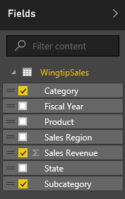

1. Now, the current report page should display a second visual like the one shown in the following screenshot. Note that you will likely need to resize this visual so it displays all its data without clipping out the content on the right-hand side.

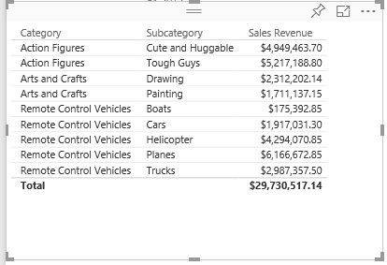

1. Change the type of visualization from table to matrix by clicking the **Matrix** button in the **Visualizations** list.

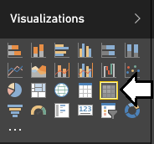

1. Now, the second visualization should display as a matrix instead of a standard table.

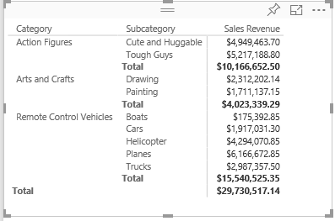

1. Inside the matrix, click on the **Sales Revenue** column header to resort the data in the matrix so that the product categories and subcategories with the highest amounts of sales revenue are sorted to the top of the matrix.

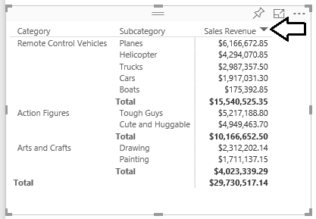

1. Increate the font size of the matrix visual.
   1. Make sure the visual with the matrix you have just created is selected as the active visual.
   2. Find the **Text Size** property in the **General** section of the **Format** properties pane and set the **Text Size** to **10pt**.

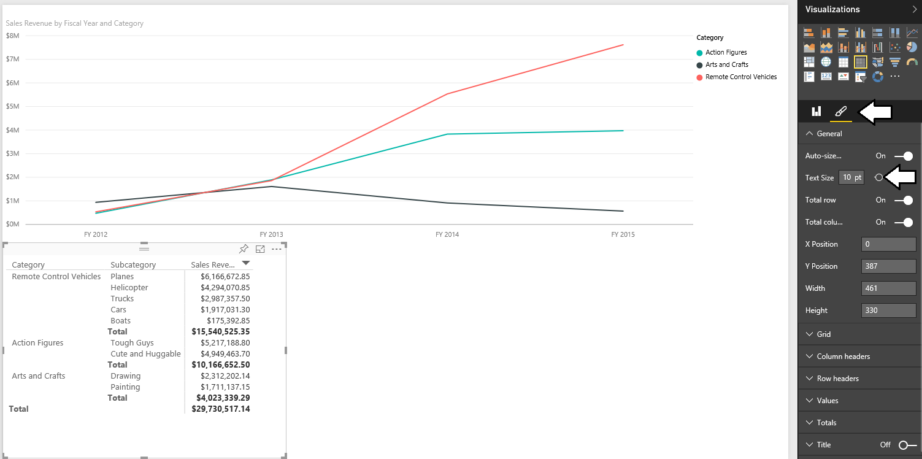

1. Customize the column header row of the matrix.
   1. Make sure the visual with the matrix you have just created is selected as the active visual.
   2. Find the **Column headers section** in the **Format** properties pane.
   3. Set the **Font color** property to **white** and the **Background color** property to **black**.

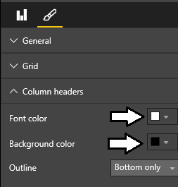

* 1. You should see the row with the column header is now stylized.

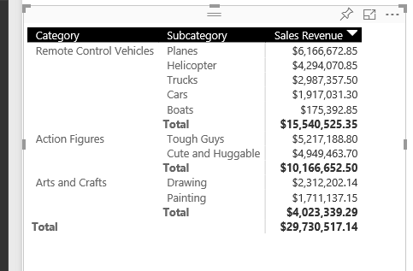

1. Add a third visual to the current report page.
   1. Click the white space on the report page outside of the two existing visuals so that neither visual is selected.
   2. Return to the **Fields** list and select the checkbox beside the **Sales Region** field.
   3. Select the checkbox beside the **Sales Revenue** field.
   4. After creating the new visual, change the visualization type to a to a **Clustered bar chart** using the **Visualizations** list.

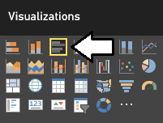

* 1. Using the mouse, reposition the new visual so it takes up the bottom right corner of the page.

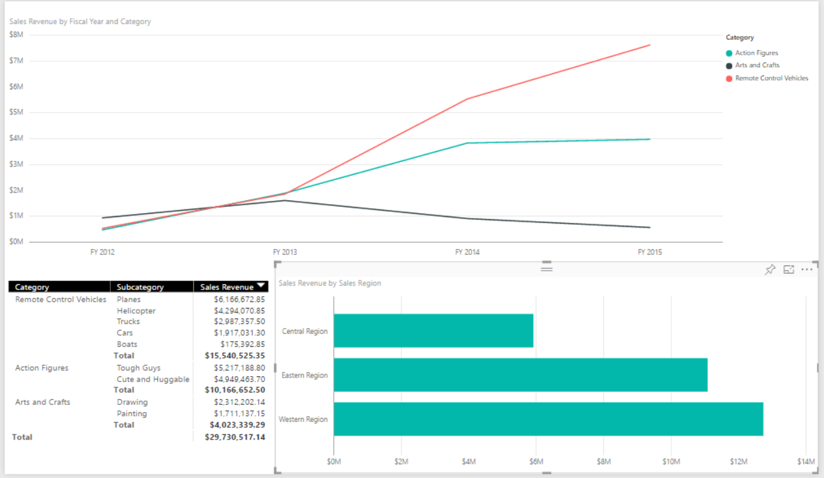

1. Add a legend to the Clustered bar chart to visualize how revenue breaks down across product categories.
   1. Make sure the Clustered bar chart visual is selected.
   2. Click on the chart icon in the **Visualizations** task pane so you can edit the **Field** properties of the new **Clustered bar chart**.
   3. Drag the **Category** field from the **Fields** list into the **Legend** well in the **Field** properties pane.

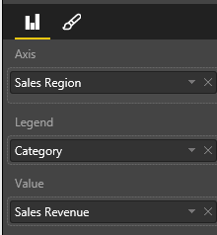

* 1. You should not see revenue for each sales region is further broken out by product category.

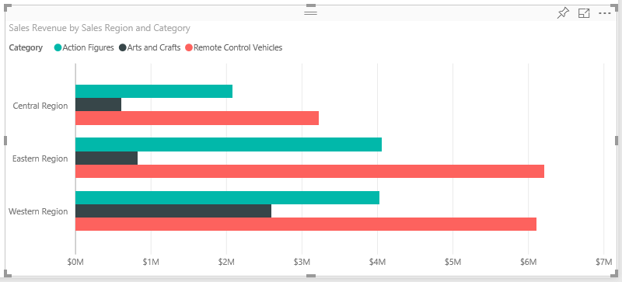

* 1. Modify the position of the legend for the Clustered bar chart to the right.

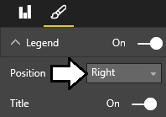

* 1. Your Clustered bar chart should now look like the one in the following screenshot.

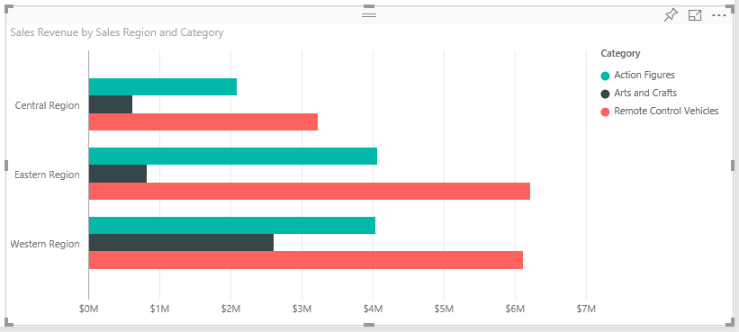

If you have time, you might explore the other options available for editing the appearance of a visualization by examining the other options that are available on the **Visualizations** task pane when a visual is selected. Note that the set of available options change depending on what type of visual is selected.

1. Now it is time to save the report. Begin by changing the name of the current page. Locate the report page name section at the bottom left of the current page and observe that the page has been given an initial name of **Page 1**.

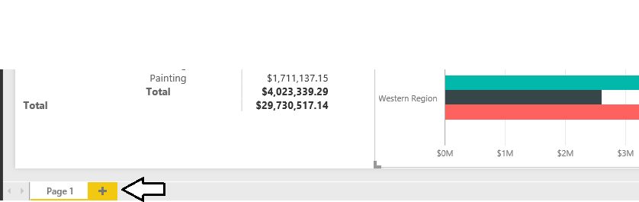

1. Double click on the page name of **Page 1** to enter edit mode and then update the page name to **Sales by Product Category**,



1. Save the report by dropping down the reports **File** menu and selecting the **Save As** menu command.

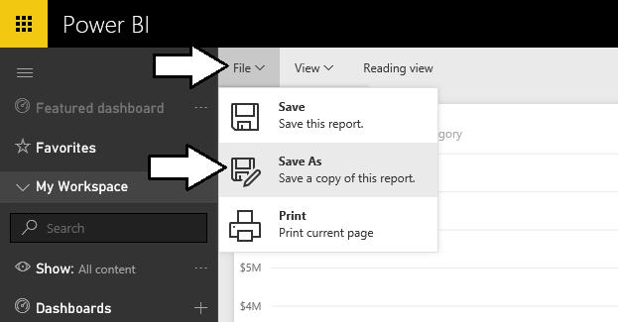

1. When prompted, enter a report name of **Product Sales** and click the **Save** button.

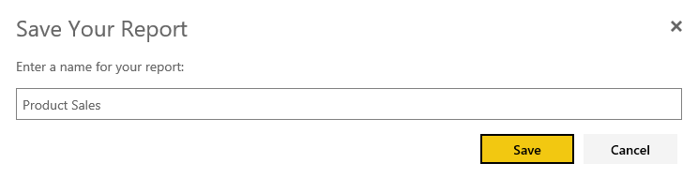

1. After saving the **Product Sales** report, you should be able to see a link for it in the **Reports** section of the left-hand navigation.

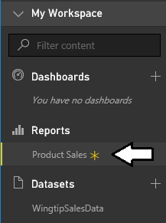

1. Now, add a second page to the **Product Sales** report. Accomplish this by clicking the button with the plus (+) sign to the right of the page name. The Power BI service will respond by creating a second page named **Page 1**.



1. Change the name of the second page from **Page 1** to **Sales by Product**.



1. On the new **Sales by Product** page, add a new visual by selecting the checkbox beside the **Product** field from the **Fields** list. This should create a simple table visual with a list of products. Resize the height of the visual to display all products at once without the need for a scrollbar.

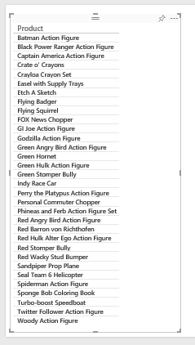

1. Change the type of visualization from a table to a slicer by clicking the **Slicer** button in the **Visualizations** list.

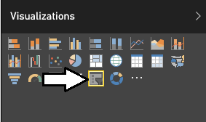

1. Now that the visualization has been changed to a slicer, you should see that each product has an associated checkbox.

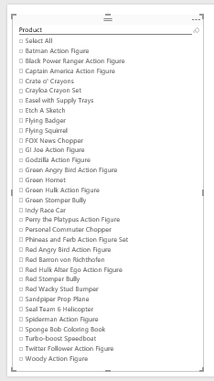

Keep in mind that this slicer visual adds the ability for the current user to intact with this report by selecting one or more products using these checkboxes. When a user changes the selection of products, the Power BI service will automatically refresh the other visualizations on the page by filtering the results using the selected product or products. Learning how to make reports interactive is a key to creating effective BI solutions with Power BI.

1. Add a second visualization to **Sales by Product** page.
   1. Click whitespace in the report to ensure the first visualization is not selected.
   2. Create a new visualization by selecting the checkbox for the **Sales Revenue** field and then selecting the checkbox for the **Fiscal Year** field.
   3. Use the mouse to reposition the new visual so it takes up the top right corner of the page.
   4. The new visual as a bar chart should now match the following screenshot.

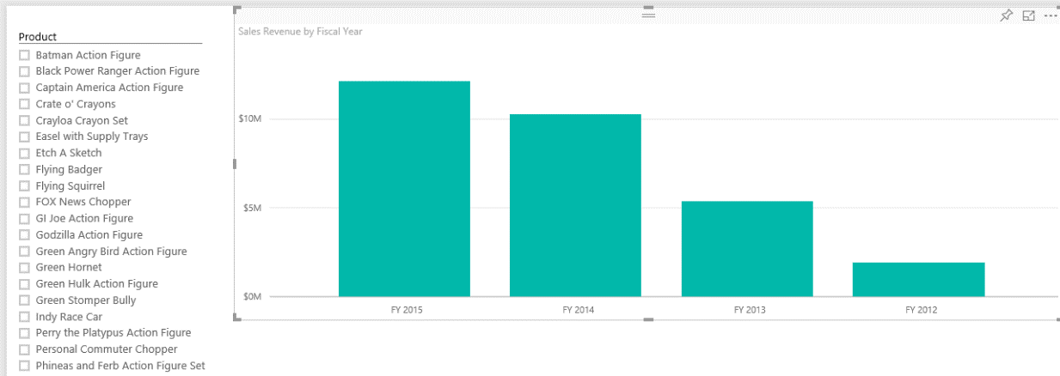

Note that the bar chart has been created with the fiscal years decreasing as it moves from left to right. In the next step you will reverse the order of the columns in this bar chart so that columns for earlier years are sorted to the right and that later years are sorted left.

* 1. Click the flyout menu at the top-right corner of the bar chart visual and select **Sort By Fiscal Year** menu command.

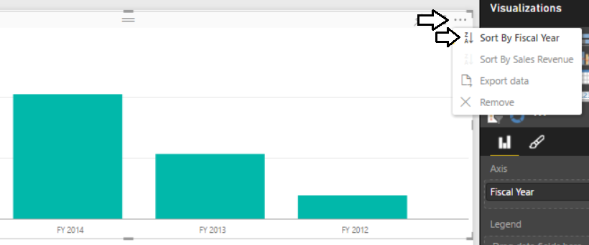

* 1. The bar chart should now display its bars with fiscal year increasing as you move to the right.

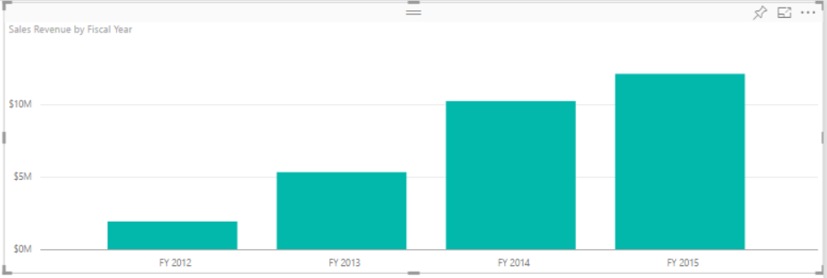

* 1. With the bar chart selected, look inside the **Format** properties pane and locate the **Data colors** section. Inside the **Data colors** section, you should see that the **Show all** property is set to **Off**.

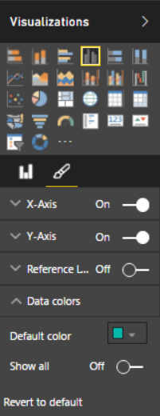

* 1. Change the **Show all** property to **On**.
  2. Assign a different color to each of the 4 fiscal years.

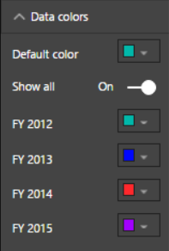

* 1. Your bar chart should now display bars that have a different color for each year.

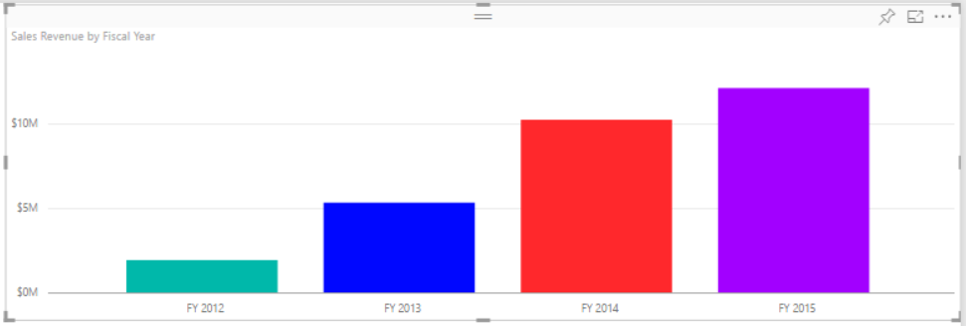

1. Add a third visual to the page.
   1. Click whitespace in the report to ensure the neither of the two visualizations are currently selected.
   2. Create a third visualization by selecting the checkbox for the **Sales Revenue** field and then selecting the checkbox for the **Sales Region** field.
   3. Use the mouse to reposition the new visual so it takes up the bottom right corner of the page.
   4. The new visual should now match the following screenshot.

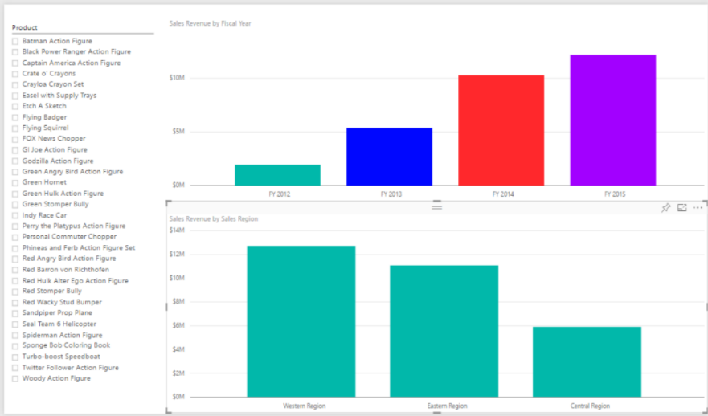

* 1. Modify the **Data colors** section in the **Format** properties pane to give each column its own unique color.

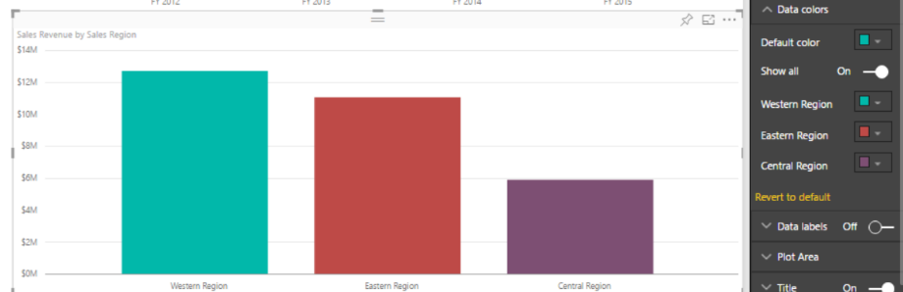

* 1. Save you work by executing the **Save** command from the **File** menu.

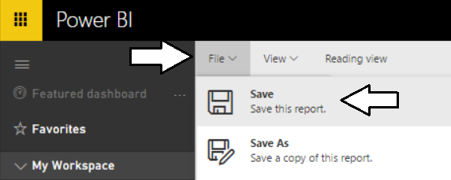

1. Test out the interactive effect of selecting products in the slicer.
   1. Select one product at a time.

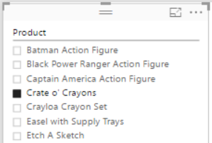

* 1. Observing how the two other visualizations on the page automatically refresh to show sales data for one product at a time.

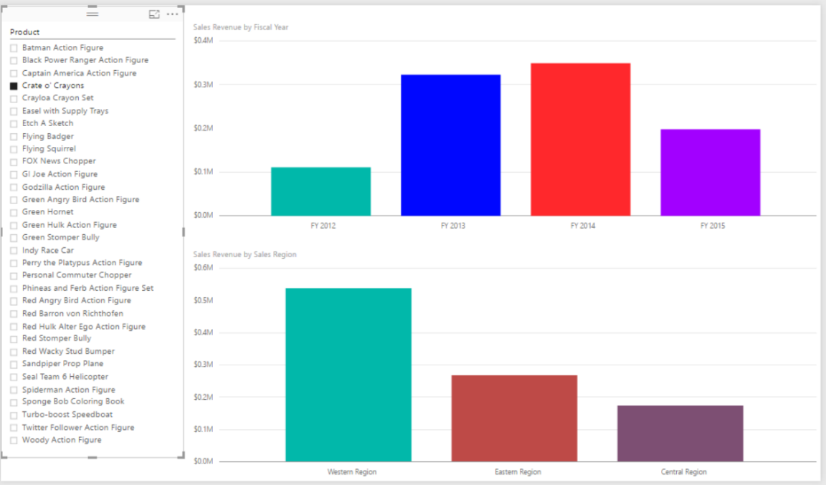

* 1. Play the role of a business analyst and determine which products have the most positive increases in sales revenue from year to year. Also, find the products with downward trending sales. If you examine the sales data for the **Crate o’ Cranyons**, you can sales revenue for this is trending in the wrong direction over the last four years. What other products are shows decreasing sales in this set of 32 products?

Now that you have created a report with multiple pages, it is time to move on to the next exercise where you will create a new dashboard and then you will test sharing this dashboard with another user in your Office 365 trial tenant.

### Exercise 7: Create and Share a Power BI Dashboard

While you have already created a dataset and a report, you must create a dashboard to effectively share a customized BI solution with other users. This final setup task will walk you through the steps of creating and sharing a Power BI dashboard.

1. Navigate to the **Sales by Product Category** page of the **Product Sales** report.
2. Inspect the Clustered bar chart with product categories. Locate and click the button with the thumbtack icon which is used to pin a report visualization to a dashboard.

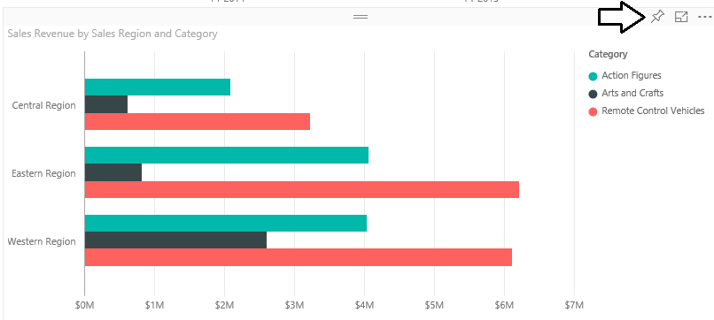

1. When you click the button with the thumbtack icon, you will be prompted with the dialog which asks you where to pin the visualization. Select the option to pin the visualization to a **New Dashboard** and give the new dashboard a name of **Product Sales**. When the **Pin to Dashboard** form is filled out like the one shown in the following screenshot, click the **Pin** button.

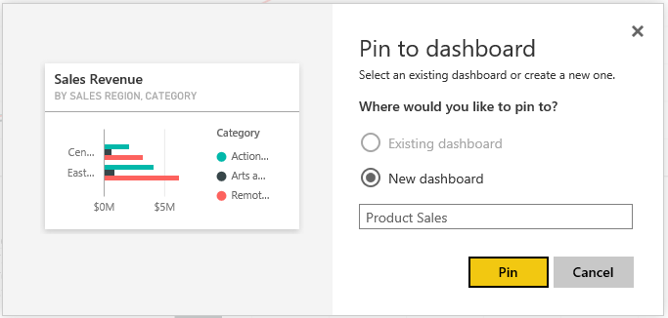

1. At this point, the new **Product Sales** dashboard should be created and a link to it should appear in the left navigation menu.

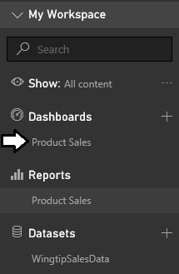

1. Navigate to the **Sales by Product** page of **Product Sales** report and follow the same steps to pin the bar chart visualization showing sales revenue by fiscal year to the **Product Sales** dashboard.

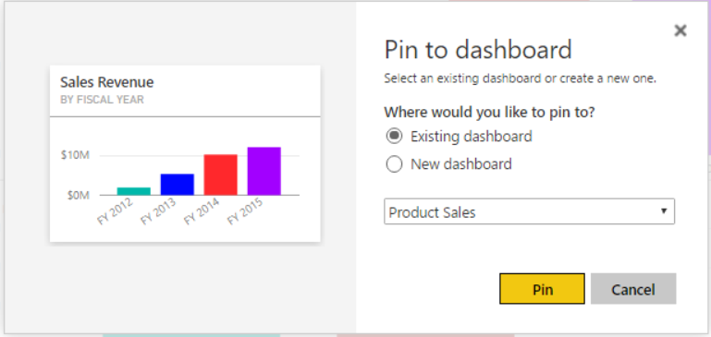

1. Remain on the **Sales by Product** page of **Product Sales** report and follow the same steps to pin the bar chart visualization showing sales revenue by sales region to the **Product Sales** dashboard.

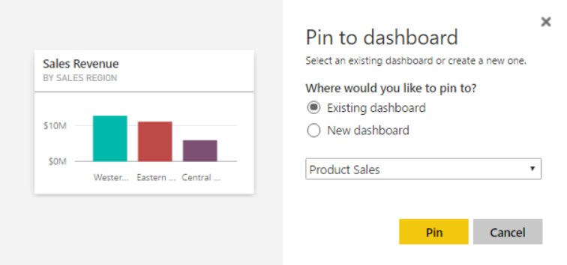

1. Click on the **Product Sales** link in the **Dashboards** section of the left navigation menu to display the **Product Sales** dashboard. You should be able to verify that you see three tiles that have been created from the three report visualization that you pinned to this dashboard.

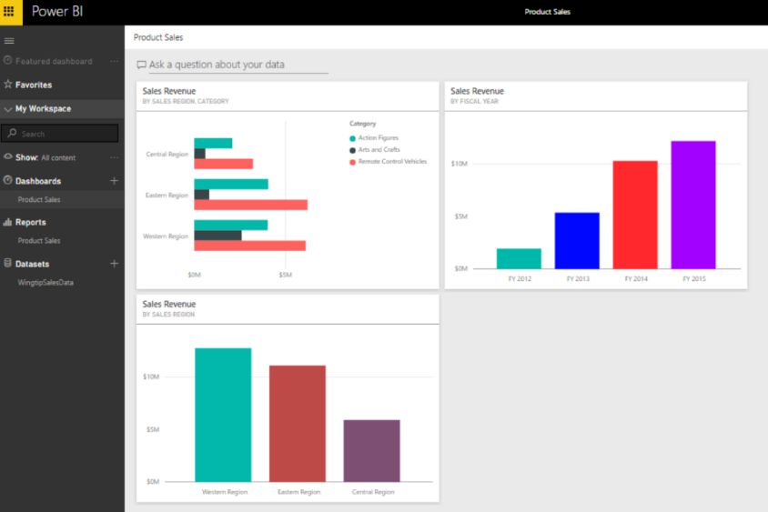

1. Note that you can move or resize the tiles inside the dashboard. This is due to the fact that you are the dashboard author and you are in dashboard edit mode. Use your mouse to rearrange the tiles in the dashboard to match the screenshot below.

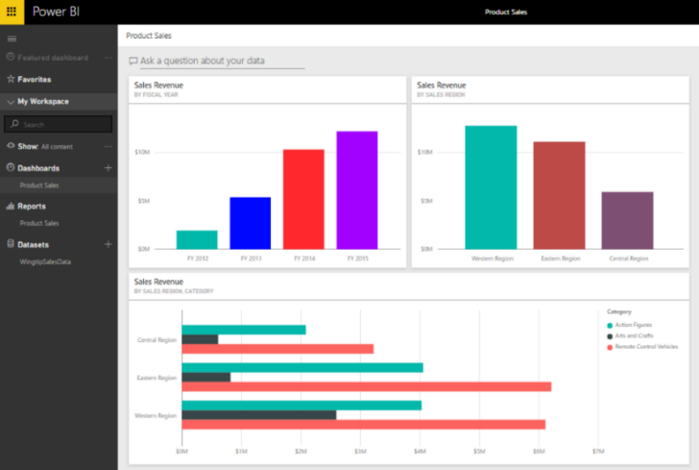

1. Experiment by clicking on the tiles in the dashboard. You will find that clicking a tile will navigate the user to the report and page that contains the visualization which was pinned to the dashboard.
2. Now, it is time to test sharing a Power BI dashboard. Start by dropping down the fly out menu for the **Product Sales** dashboard and clicking the **SHARE** menucommand .

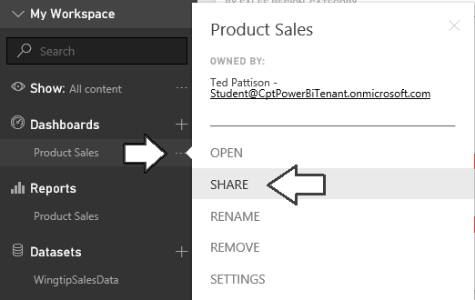

1. At this point, you are prompted with the **Share dashboard** page where you can add the users and/or groups with which you want to share your new dashboard. Enter the email address of the secondary user account that you created earlier in setup task five that has an email address of **JamesB@CptPowerBiTenant.onMicrosoft.com**. After you have entered the email address, click the **Share** button at the bottom of the page.

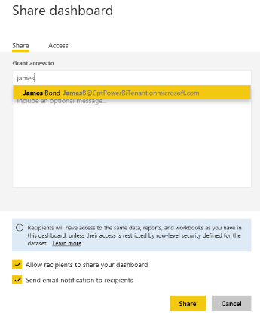

1. Once the dashboard has been successfully shared, you should be able to confirm that the secondary user has access to this dashboard by returning to the **Share dashboard** dialog and examining the **Access** tab of the **Share dashboard** page as shown in the following screenshot.

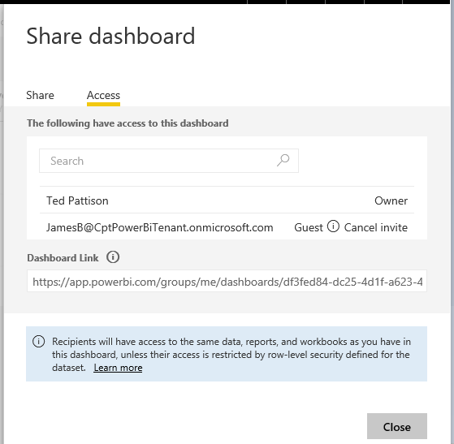

Now you have completed the steps to share the dashboard. The final step is to test the experience of a user who is not the dashboard author, but instead a dashboard consumer. This will require that you sign out of the Power BI service and then sign back in under the identity of the secondary user account. By accessing the shared dashboard in this fashion, you will be able to observe the typical experience of a dashboard consumer when accessing a dashboard that has been shared by another user.

1. Drop down the user menu from the top, right-hand corner of the page and click the Sign out command.

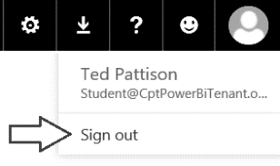

1. Now, sign back in using the account name and the password of the secondary user account for which you just shared the **Product Sales** dashboard.

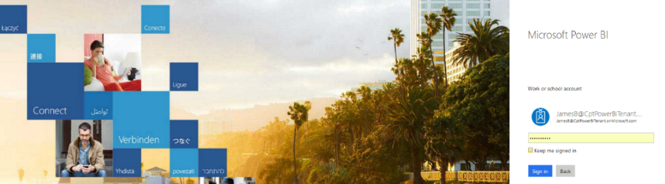

1. Once you have signed in, click the **Mail** tile in the Application Launcher accessible via the **Waffle** **Button**.
2. When you first log into mail, you will be prompted to set a time zone. Once you set the time zone, you should be redirected to the Exchange Online inbox for the secondary user.
3. Once you are able to access the inbox for the secondary user, you should be able to verify that the Power BI service has sent this user a notification email message informing the user that the Product Sales dashboard that has been shared. In the body of the email message, click the **Open Product Sales** link to navigate to the new dashboard.

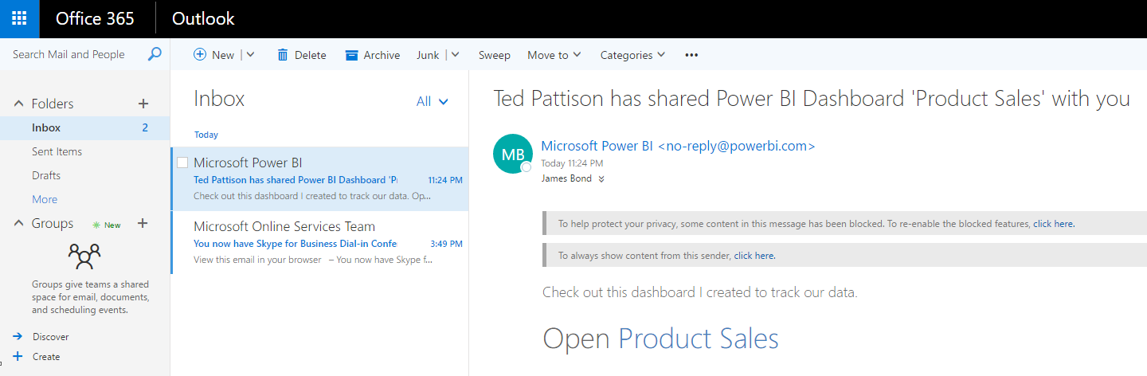

1. At this point, you will be taken to a page which shows the personal workspace for the current user and displays the page for the Product Sale dashboard.

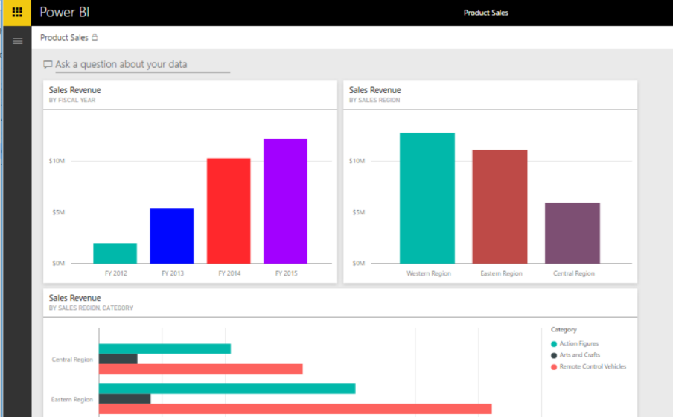

1. Expand the left navigation menu. Take note that this user can see the **Product Sales** dashboard link in the left navigation menu but this user does not see any links for the underlying report or dataset.

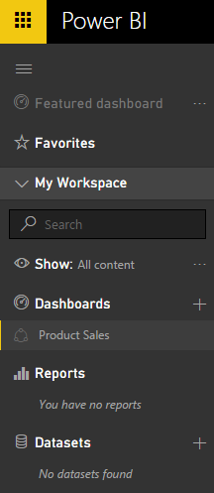

Note that Power BI does not include links to provide the dashboard consumer with direct access to the report or the dataset behind the dashboard. However, Power BI does supply the dashboard consumer with indirect access to the report and the dataset behind the dashboard. It’s just that the dashboard consumer can only access the report and dataset by interacting with the dashboard. One key benefit is that this approach keeps the left navigation less cluttered when the user is accessing many different shared dashboards.

1. Navigate to the **Product Sales** dashboard and observe that the dashboard page is in read-only view. The user is not able to delete, move or resize any of the tiles. Only the dashboard author is able to edit this dashboard page.
2. On the **Product Sales** dashboard, experiment by clicking on the dashboard tile showing sales revenue by fiscal year. This will allow you to navigate to the **Sales by Product** page of the **Product Sales** report. Interact with the report page by using the slicer to filter and analyze the underlying data and see how individual products are selling from year to year.

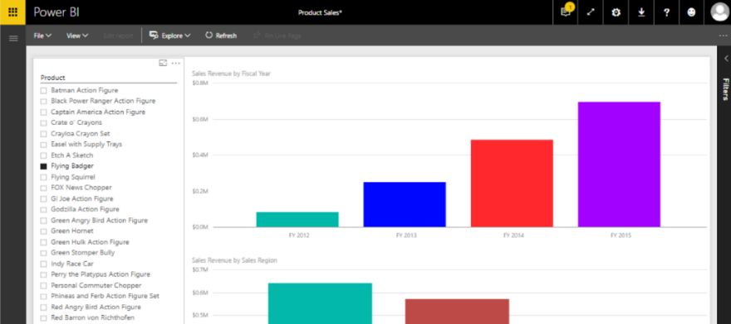

### Exercise 8: Get Quick Insights on a Power BI Dataset

In this exercise, you will run a Power BI command to generate quick insights for the WingtipSalesData dataset.

1. Log out from the JamesB account and then log back in using your primary user account.
2. Drop down the fly out menu for the **WingtipSaleData** and click the **VIEW INSIGHTS** menu command.

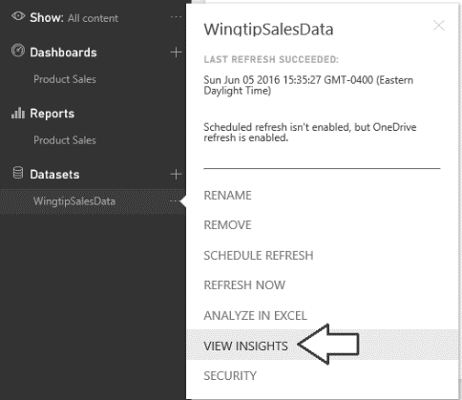

1. After a second or two, the Power BI service should generate a page with the title **Quick Insights for WingtipSalesData**. Take a few minutes to review all the quick insights that have been generated.

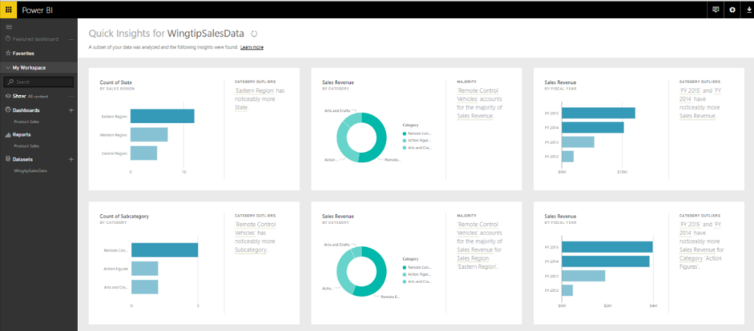

Congratulations. You have made it to the end of this setup guide and you have now created and configured a test environment in which you can begin to create and implement custom BI solutions using the Power BI platform.